Linux exercise 5-Editors and utilities
- Create the tar archive from dir2 directory created in previous exercise (Linux exercise 4 - Basic commands) and compress it using gzip.
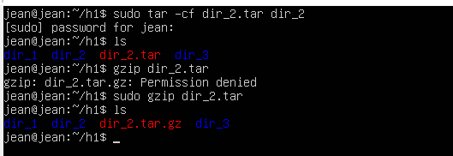
- Open one of the files you have created earlier with text editor of your choice. Add text to the file and save it with different name.
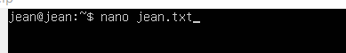
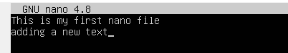
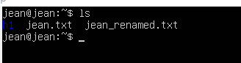
- Open some file using less command. Find out how search feature works in less command.
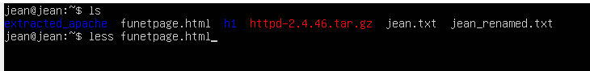
- Download and extract the Apache web server package: Apache web server.( I couldn’t see the provided link for apache download so I downloaded from another source.)
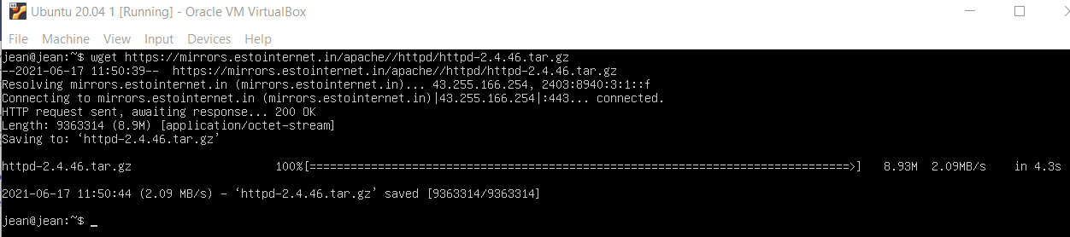
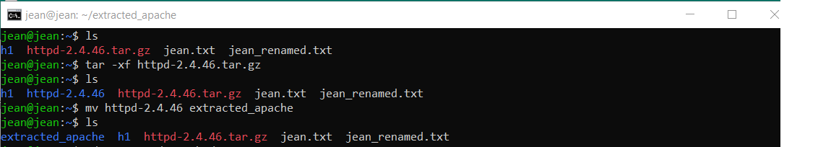
- Use Vim editor in this task. Open CHANGES file from extracted Apache web server directory and add this line to the beginning of the file:
  - ====== This file has been edited in current_date ======
  - Save the file and print first 18 lines of the file to the command line.
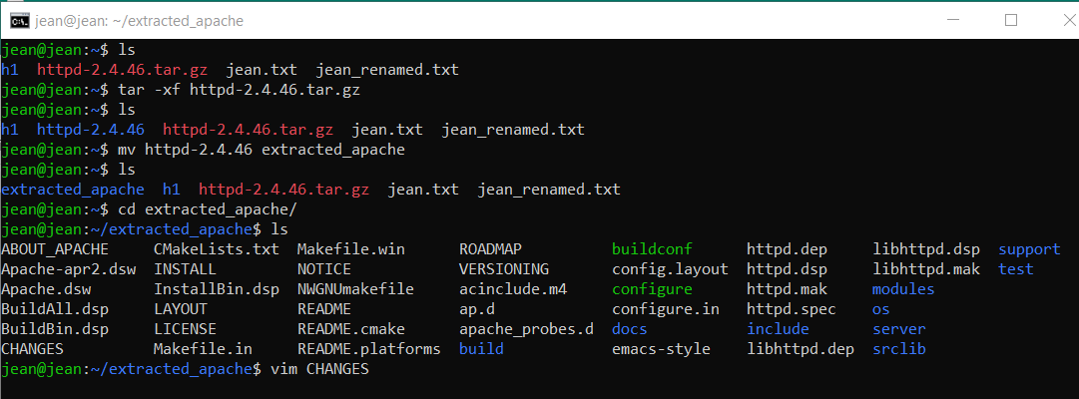
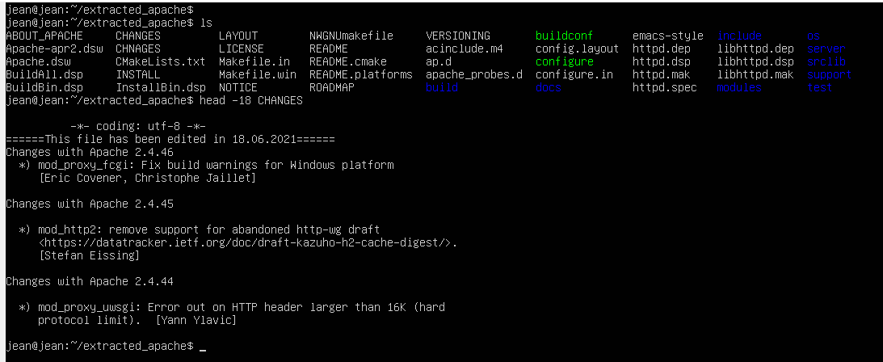

- Open Kernel log file (/var/log/kern.log) using tail command so that new log lines are listed in real-time.
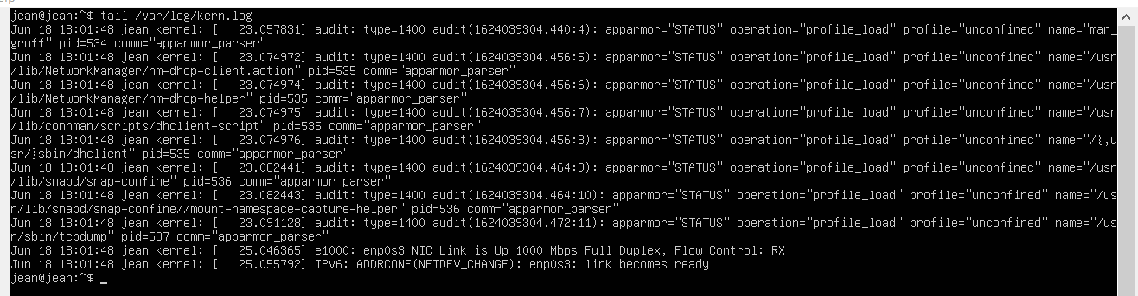
- Examine curl program parameter through help feature. Download Funet network's wiki page https://fi.wikipedia.org/wiki/Funet and save the content of the page to the file (Write to file) called funetpage.html. Add screenshot presenting part of this file's content.
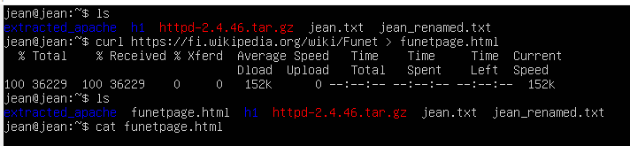
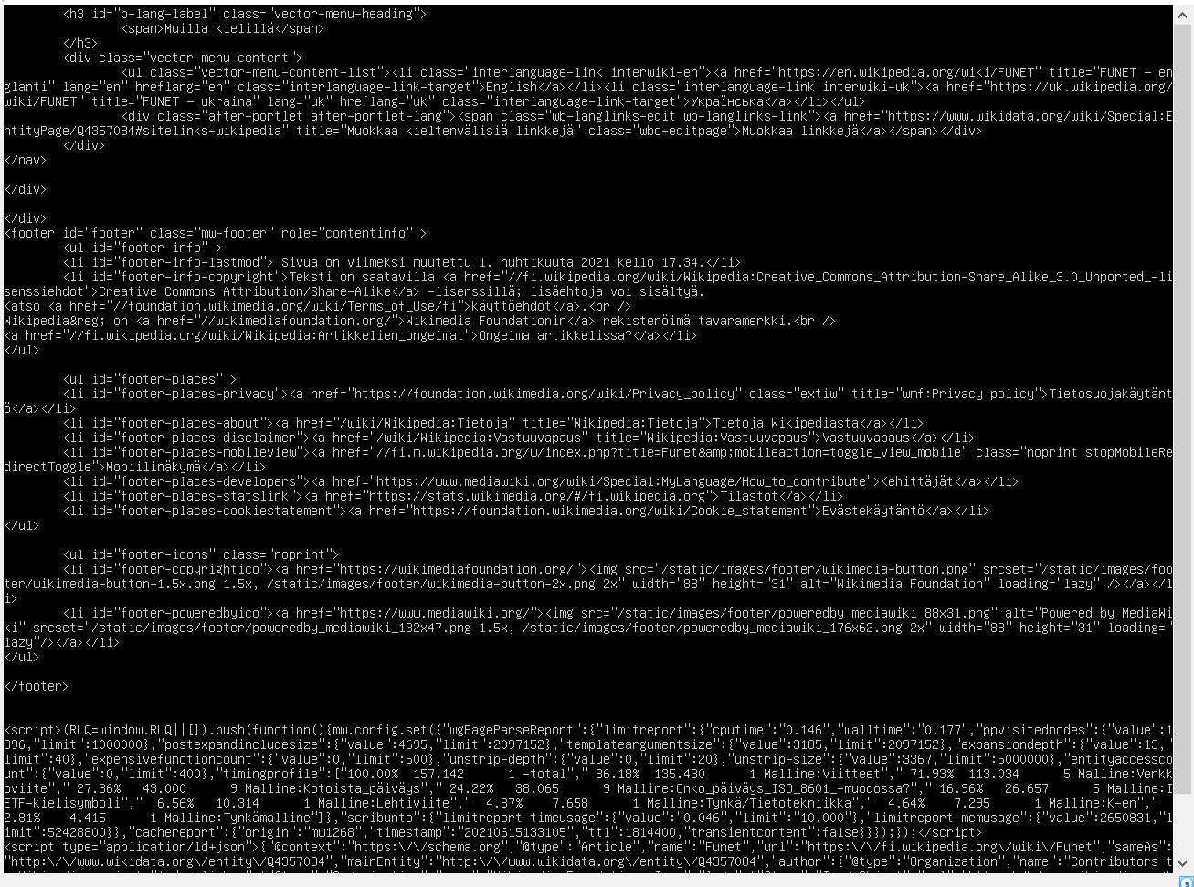

- In this task curl command will be used to connect to remote servers:
a) README file is located in the server http://ftp.funet.fi. How do you open this file using curl command so that you can view it page by page (hint: utilize other commands with curl)?
b) How do you list the content of remote server's folder ftp://speedtest.tele2.net/? What files are included in listing?

